# Mercola Health Coach App: Epic and Feature Blueprint

## Document Overview

This document serves as a comprehensive guide to the structure and functionality of the **Mercola Health Coach App**. It outlines key **Epics** (major modules) and their respective **Features** (specific functionalities), providing stakeholders with a clear understanding of how the app is designed to meet user needs. Each section includes detailed descriptions, user interactions, layman’s explanations, and impact goals to illustrate the strategic value of each component.

## Purpose of the Document

This blueprint is intended for stakeholders—including product managers, developers, designers, and business leaders—who need a deep understanding of the app's architecture, user flows, and strategic objectives. It aligns technical implementation with business goals, ensuring that all teams are working cohesively toward a shared vision.

## How to Use This Document

* **Stakeholders**: Gain insights into the app's user-centric design and how each feature contributes to engagement, retention, and revenue growth.
* **Developers**: Use this as a functional guide for implementing the app’s features and ensuring alignment with the intended user experience.
* **Designers**: Reference the feature details to create intuitive, visually engaging user interfaces.
* **Business Leaders**: Understand the app’s capabilities and potential for scalability to inform decision-making and resource allocation.

## Visual Reference

The included diagram (to be added) complements this document by mapping user flows and interactions across the app's major modules. It visually represents how features are interconnected, simplifying complex workflows for stakeholders.

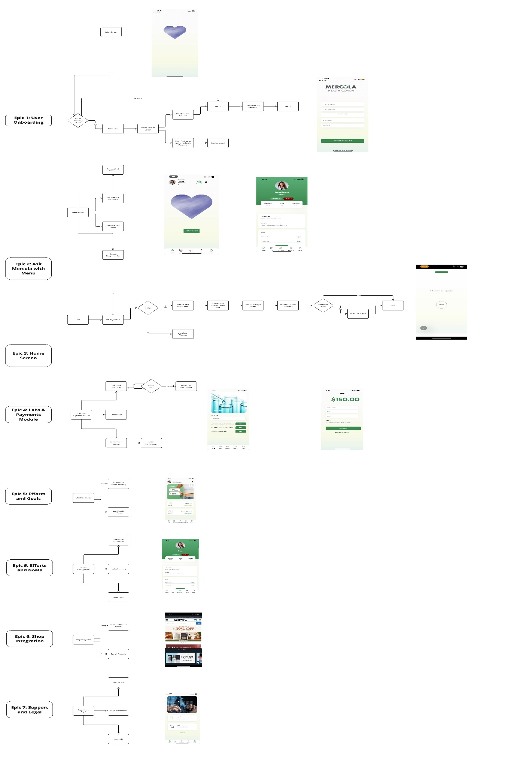

## Epic 1: User Onboarding Process

### Expanded Description:

The User Onboarding Process introduces new users to the app and provides an intuitive and seamless flow for account creation and returning user login. It begins with a branded splash screen and offers users the option to create an account or log in. The Create Account screen includes fields for capturing user information such as first name, last name, email, and password, ensuring the app delivers personalized experiences from the start.

### What the Epic Does:

* **Purpose**: Welcomes both new and returning users while ensuring smooth account creation and login for personalized app usage.
* **User Interaction**:
  + New users are greeted with a branded splash screen and prompted to either get started or create an account.
  + Returning users are given the option to log in directly.
  + The Create Account screen captures essential user details for onboarding.

### Features:

#### Splash Screen:

* Initial welcome screen with branding and navigation to onboarding options.

#### Get Started Option:

* Path for new users to begin the guided onboarding experience.

#### Have an Account Option:

* Shortcut for returning users to log in using email and password.

#### Create Account Screen:

* Form fields to input first name, last name, email, and password.
* Includes a "Create Account" button for submission.
* Example text: “Enter Firstname, Lastname, Email, Password.”
* Link for existing users: “Already have an Account?”

### Layman’s Terms Explanation:

This is the first step into the app. If you’re new, you can create an account by entering your name, email, and password. If you’ve already signed up, just log in and pick up where you left off.

### Impact Goals:

* **Streamline User Access**: Makes it easy for new users to sign up and returning users to log in.
* **Enhance Personalization**: Captures user data upfront to provide tailored health insights.
* **Improve Retention**: A welcoming and seamless onboarding process encourages continued app usage.

## Epic 2: Ask Mercola / Ask the Coaches

### Expanded Description:

This feature empowers users to interact with expert advice by asking health-related questions directly within the app. It leverages advanced AI technology, including the Llama Index, to deliver personalized responses drawn from a comprehensive knowledge base. While the current version integrates insights from the **Cellular Health Book**, the functionality is designed to scale by incorporating additional sources such as newsletters, articles, research papers, and other books. This adaptability ensures the feature evolves into a robust and ever-expanding repository of health knowledge.

#### **What the Epic Does:**

**Purpose**: Provides users with a one-stop platform to ask health-related questions and receive curated, personalized answers from reliable sources. This enhances user engagement and positions the app as a trusted resource for health and wellness guidance.

**User Interaction**:

Users tap the "Start" button to initiate their query.

Prompts are processed through Llama Index, which analyzes user inputs against the knowledge base.

Responses are dynamically generated using Cellular Health content and other integrated resources.

### Features:

#### Prompt Submission:

* Users can input personalized health questions via a clean and intuitive interface.

Example: “Click Start to ask a question.”

#### Dynamic Content Integration:

* Draws from the Cellular Health Book and seamlessly integrates other content in future iterations, such as newsletters, articles, and books.

#### AI-Powered Insights:

* Processes complex inputs to deliver simplified, actionable responses.
* Leverages the Llama Index to match queries with the best resources.

#### Data Collection and Reporting:

* Tracks user behavior and interaction trends to:
* Identify gaps in the knowledge base.
* Deliver user-relevant updates.
* Create reports for ongoing feature improvements.

#### Help Button:

* A visible "Help" button offers guidance on how to ask effective questions.

### Layman’s Terms Explanation:

Think of this as your personal health expert. You ask a question, and the app searches through trusted resources, like the **Cellular Health Book**, to give you the best answer. Over time, it learns from your questions and expands its knowledge to offer even better advice.

### Impact Goals:

**Increase User Retention**: By consistently offering fresh, relevant, and personalized content, users will see value in returning to the app regularly.

**Enhance Credibility**: Expanding the knowledge base with high-quality content establishes the app as a leading health resource.

**Drive Engagement**: Use insights from user queries to develop targeted campaigns and features.

**Scalable Future**: As the app collects more data, it becomes more precise and adaptable.

## Epic 3: Home Screen

### Expanded Description:

The Home Screen acts as the central hub of the app, providing a personalized snapshot of the user’s health journey. It displays key metrics, such as steps and sleep, celebrates achievements, and provides seamless navigation to other app sections. It’s designed to motivate users by showing their progress and encouraging further engagement.

### What the Epic Does:

**Purpose**: Offers a welcoming and informative starting point for users, centralizing their health metrics and providing quick navigation options.

**User Interaction**:

Users see a personalized greeting with their name and profile picture.

Health data, such as steps and sleep, is displayed prominently.

Users can navigate to other sections like Labs, Efforts, Profile, and Shop with ease.

### Features:

#### Personalized Welcome:

* Display user's name, profile picture, and relevant greetings.
* Example: “Welcome, Sarah James!”
* Includes metrics like steps and sleep data.

#### Daily Metrics Dashboard:

* Highlights user’s progress for steps and sleep.
* Metrics shown: Total steps with timestamp, total sleep duration.

#### Achievements Section:

* Display awards or achievements (e.g., Food, Exercise).

#### Bottom Navigation Bar:

* Quick access to primary sections: Home, Labs, Efforts, Profile, and Shop.

### Layman’s Terms Explanation:

The Home Screen is your health dashboard. It greets you by name, shows your progress with steps and sleep, and celebrates your achievements. You can quickly get to any part of the app from here.

### Impact Goals:

* **Increase Engagement**: By displaying relevant health data, the Home Screen motivates users to track their progress daily.
* **Simplify Navigation**: Centralizes key app functions for easier access.
* **Enhance Personalization**: Dynamic updates create a user-centric experience.

## Epic 4: Labs and Payments Module

### Expanded Description:

This module simplifies the process of browsing, selecting, and purchasing lab tests. Users can explore available tests, such as CBC and Lipid Panels, add them to a cart, and complete their purchase through a secure payment gateway. It provides transparency in pricing and ensures a smooth checkout process.

#### What the Epic Does:

**Purpose**: Makes lab test purchases straightforward while ensuring secure transactions and clear pricing.

**User Interaction**:

Users browse available lab tests and select the ones they need.

They add selected tests to their cart and proceed to a secure payment gateway.

A confirmation screen displays their order details upon payment completion.

### Features:

#### Lab Tests Overview:

* Show available lab tests with descriptions and pricing.
* Includes options like CBC, BMP, Lipid Panel.

#### Add to Cart Functionality:

* Allow users to select and add lab tests directly.

#### Search Labs:

* Search bar for filtering lab test options.

#### Lab Payment Gateway:

* Payment gateway for lab tests, including fields for card details, CVV, and shipping address.

#### Order Confirmation:

* Display order summary and confirmation after payment is completed.

### Layman’s Terms Explanation:

Need a lab test? This module makes it easy to choose and pay for tests like a CBC or Lipid Panel. You’ll get clear pricing, a secure checkout, and a confirmation to keep everything on track.

### Impact Goals:

**Enhance Accessibility**: Makes lab tests readily available to users.

**Secure Transactions**: Builds trust with a reliable payment process.

**Drive Data Insights**: Collect user behavior data to identify popular lab tests and expand offerings.

## Epic 5: Efforts and Goals

### Expanded Description:

This feature tracks and celebrates user progress in health and wellness efforts. From food and exercise awards to physical activity tracking, it motivates users to stay consistent and build positive habits through visual progress displays.

#### What the Epic Does:

**Purpose**: Encourages users to track their efforts and feel rewarded for consistent progress.

**User Interaction**:

Users see their efforts visualized as awards for food, exercise, or other activities.

Detailed tracking of efforts such as nutrition and physical activity is provided.

### Features:

#### Awards and Efforts Tracking:

* Visualized awards for Food and Exercise.

#### User-Specific Efforts:

* Track user actions like nutrition and physical activity.

### Layman’s Terms Explanation:

This is your personal cheerleader. The app tracks your efforts in food and exercise, giving you awards and helping you see how far you’ve come. It’s all about motivation and progress.

### Impact Goals:

**Increase Motivation**: Encourages users to maintain healthy habits.

**Boost Engagement**: Keeps users invested in their progress.

**Personalized Support**: Tailors insights based on tracked efforts.

## Epic 5: Profile Management

### Expanded Description:

The Profile Management module provides users with a centralized space to view, update, and manage their personal and health-related information. By enabling the editing of key details such as weight, height, and allergies, this module ensures the app delivers personalized insights. It also includes a logout option for enhanced security and convenience.

#### What the Epic Does:

* **Purpose**: Allows users to manage their personal information to ensure accurate and tailored health insights.
* **User Interaction**:
  + Users can view and edit their profile details such as weight, height, and allergies.
  + Health metrics are summarized in a user-friendly layout.
  + A logout button ensures users can securely exit the app.

### Features:

#### Edit Profile Information:

* + Edit user details such as name, weight, height, and allergies.
  + Example: Users can update their weight for personalized calorie tracking.

#### Health Summary:

* + Highlight user’s key health metrics for quick reference.

#### Logout Button:

* + Quick option to log out of the app for security.

### Layman’s Terms Explanation:

This is your control center. You can update your personal info, like your weight or allergies, to make sure the app gives you accurate advice. You can also log out to keep your account secure.

### Impact Goals:

* **Enhance Personalization**: Accurate user data ensures tailored insights.
* **Improve Security**: Logout functionality safeguards user accounts.
* **Increase User Trust**: Easy access to manage personal data builds confidence in the app.

## Epic 6: Shop Integration

### Expanded Description:

The Shop Integration module connects users to the Mercola Market, allowing them to browse and purchase health-related products. By integrating e-commerce functionality directly into the app, this module enhances user convenience and aligns with their health goals.

#### **What the Epic Does:**

* **Purpose**: Offers a seamless shopping experience for health-focused products.
* **User Interaction**:
  + Users access the Mercola Market to browse products, view discounts, and explore deals.
  + A search bar helps users find specific items.
  + Discounts and offers are displayed prominently to encourage purchases.

### Features:

#### Access to Mercola Market:

* + Integration with the Mercola Market for browsing products.
  + Example: Show discounts and product offers.

#### Search Products:

* + Search bar for browsing specific items on the market.

### Layman’s Terms Explanation:

This is your health shopping cart. You can browse the Mercola Market for supplements, wellness products, and more—all without leaving the app. Search for what you need and grab the latest deals.

### Impact Goals:

* **Increase User Convenience**: Simplifies access to health-related products.
* **Boost Engagement**: Keeps users within the app for shopping needs.
* **Drive Revenue**: Encourages purchases by showcasing discounts and offers.

## Epic 7: Support and Legal

### Expanded Description:

The Support and Legal module provides users with access to FAQs, contact options, and key legal information. This ensures that users have the assistance they need and understand the app's terms of use and policies. An "About Us" section offers transparency about the app’s mission and values.

### What the Epic Does:

* **Purpose**: Ensures users have the resources and information they need for a seamless experience.
* **User Interaction**:
  + Users access FAQs or contact support for assistance.
  + Legal information such as terms of use is readily available.
  + The "About Us" section provides insight into the app’s purpose and creators.

### Features:

#### Help Section:

* 1. Provide user assistance with FAQs or direct contact options.

#### Legal Information:

* 1. Access to legal information or terms of use.

#### About Us:

* 1. Provide details about the app’s mission and organization.

### Layman’s Terms Explanation:

This is where you go for help. Need answers? Check the FAQs or contact support. Curious about the app’s mission or policies? It’s all here in the "Legal" and "About Us" sections.

### Impact Goals:

* **Increase User Trust**: Transparent legal information builds credibility.
* **Improve Support**: Ensures users can get help when they need it.
* **Enhance Engagement**: Clear communication about the app’s purpose fosters loyalty.